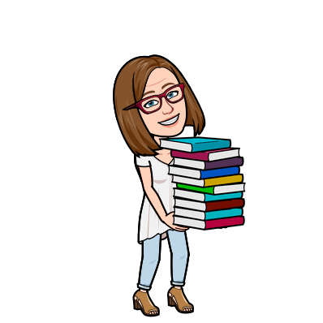
Yay! You’re getting a library book!

Here’s what you need to know:
AFTER Mrs. Rechs emails you to tell you that your books are ready, please come by to pick them up.
Pickup/drop off times and locations:

Day | Time | Location
Friday | 11am-2pm | On Harmon Drive, in front the school office and cafeteria
Friday | 6pm-7pm | Mrs. Rechs’ house  6890 Sailboat Way 95831

Safety Procedures:

- All materials will be quarantined for 5 days before distribution (the current recommended amount of time is 3 days as per California State Library guidelines - page 10)
- Mrs. Rechs will wear a mask and gloves while handling materials
- Families who drive up will stay in their cars and wear masks, materials will be brought out to cars
- If you walk up, please wear a mask and adhere to social distancing guidelines
- Books at Mrs. Rechs’ house will be clearly labeled with student names. Please find and touch only your child’s bag.
- Please do not come to distribution if you are sick or have been exposed to Covid-19. Mrs. Rechs will hold your books until you are able to pick them up.

If you have any questions or need to make alternate arrangements please contact Cathy Rechs at catherine-rechs@scusd.edu

